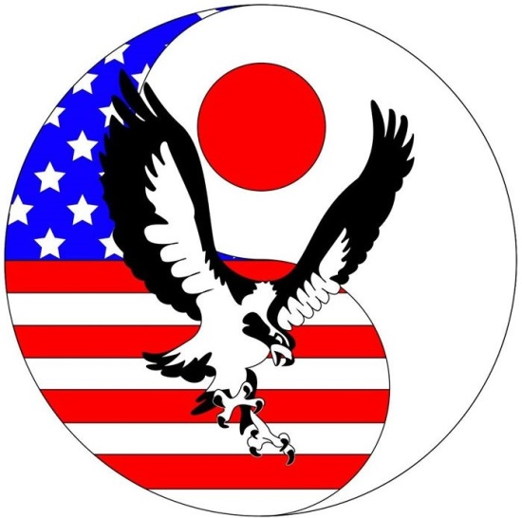
Rock
the
Blocks

Sunday, May 29, 2016
Seahawk Natatorium – Yokosuka Naval Base
Yokosuka, Japan

Pool: 50 meters x 7 lanes
Entries: Swimmers can enter up to 4 Individual Events.
Mixed Relay teams may consist of: 4 females
4 males
2 females/2 males

Entry Deadline: Sunday, May 15th
Visiting Teams - Send via email to: yokosukaswimmeet@gmail.com
YJSST Members - Enter through TeamUnify site.

Fee: Individual events $4 or ¥400
Relay events $8 or ¥800

Warm-up Time: 07:30-08:00 YJSST
08:00-08:30 All other Teams – Lane assignments will be sent at later date.
08:30-08:45 Starts – All 7 lanes, for all teams.
08:40 - Coaches Meeting
09:00 - Opening Ceremony

Continuous Warm-up: Available in Lane 8 during the meet, please no stopping/playing.
Awards: Trophy to High Points winner in each age group.
Medals 1st – 3rd Individual Events
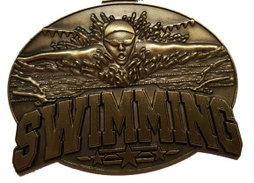
Ribbons 4th – 8th Individual Events
Medals 1st – 3rd Relay Events

Entry: Non-military teams please meet your escort at the Womble Gate at 07:30 sharp. If you need any assistance upon arrival, please call Guy Sanchez at 080 5511 4449.
Parking and Pool Entry: Ample parking is available in the Purdy Gym parking lot. Please use the stairs on front side of building. You will be entering the facility between the gymnasium and pool.
Concessions: Gatorade, water, fruit, chips, candy and other light snacks will be available for purchase. Yen is accepted on a 1:1 exchange. Swimmers and families may also use CFAY’s food court (Subway, Popeye’s, Manchu Wok, A&W, Cinnabon/Baskin Robbins/Seattle’s Best Coffee).
Payment: Entry fees will be collected by YJSST’s Treasurer, Jess Chandler, the day of the meet. Payment can be made in USD, Yen or by check payable to: YJSST.

